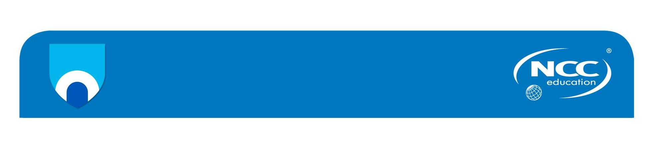

**Unit:**

**Designing and Developing a Website**

**Assignment title: Annual Charity Show (ACS)**

|  |
| --- |
| **Important notes**   * Please refer to the *Assignment Presentation Requirements* for advice on how to set out your assignment. These can be found on the NCC Education website. Click on ‘Policies & Advice’ on the main menu and then click on ‘Student Support’. * You must read the NCC Education documents *what is Academic Misconduct? Guidance for Candidates* and *Avoiding Plagiarism and Collusion: Guidance for Candidates* and ensure that you acknowledge all the sources that you use in your work. These documents are available on the NCC Education website. Click on ‘Policies & Advice’ on the main menu and then click on ‘Student Support’. * You **must** complete the *Statement and Confirmation of Own Work*. The form is available on the NCC Education website. Click on ‘Policies & Advice’ on the main menu and then click on ‘Student Support’. * Please make a note of the recommended word count. You could lose marks if you write 10% more or less than this. * You must submit a paper copy and digital copy (on disk or similarly acceptable medium). Media containing viruses, or media that cannot be run directly, will result in a fail grade being awarded for this assessment. * All electronic media will be checked for plagiarism. |

**June 2018**

Student Student ID: 00171334 Centers: DIA

Name: MD. Mostafizur Rahman

**Marker's comments:**

**Moderator's comments:**

|  |  |  |
| --- | --- | --- |
| **Mark:** | **Moderated** | **Final** |
|  | **Mark:** | **Mark:** |



**Student Declaration**

I have read and understood NCC Education’s Policy on Academic Dishonesty and plagiarism.

**I can confirm the following details:**

**Program/Qualification Name :** L4DC

**Student ID/Registration number :** 00171334

**Name :** MD. Mostafizur Rahman

**Center Name :** DIA

**Module Name :** Designing and Developing a Website

**Module Leader :** Md. Rafiqul Huq Rafi

I confirm that this is my own work and that I have not plagiarized any part of it. I have also noted the assessment criteria and pass mark for assignments.

**Due Date:** 21/04/2018

**Student Signature: Mostafizur**

**Submitted Date:** 21/04/2018

Contents

Introduction: 5

Task-03: 6

HTML and CSS validation: 6

CSS Validation Screenshot: 6

HTML Validation Screenshot: 7

Validation of Mobile. 12

Compatibility of Web Browser - 13

Google Chrome: 13

Mozilla Firefox: 16

Testing Report: 20

Task-4 21

Advantage and disadvantage of multimedia element: 21

Different types of multimedia file format. 22

Advantages: 22

Disadvantages: 22

ACS website. 23

Advantages: 23

Disadvantages: 23

Suggestion for Improvements: 23

Further Developments: 23

CSS3 for Mobile. 24

Advantages: 24

Disadvantages: 24

Conclusion: 24

Introduction:

This is a continuity where I wanted to work for developing a website. This website name is Annual Charity Show (ACS).

ACS (Annual Charity Show) this charity show mainly work for animal and they wanted to ensure animal extra facilities. The Animal charity show (ACS) wanted to develop their charity for this reason every year they promote a charity show. This charity show only for animal. For this charity show many different country are growth their help and sum up fund for this community. The website designed with 7 HTML pages as follows:

* Home
* Charity Events
* Fund Raising
* Community
* News & Reviews
* Tools & Calculators
* Join Us Now

Task-03:

HTML and CSS validation:

For this Annual charity show, this is too much needed that all tasked are show and checked the HTML and CSS pages with W3C validator (<http://validator.w3.org/>) and for mobile web to checked this in (mobile.css-validator.org). when complete this work that moment we say this is valid . when it is complete then we need all pages are run in Google Chrome and Mozilla Firefox and must be it was 1024x768 exploration as it was instructed.in the final moment I marked the all result. Results are shown below:

CSS Validation Screenshot:

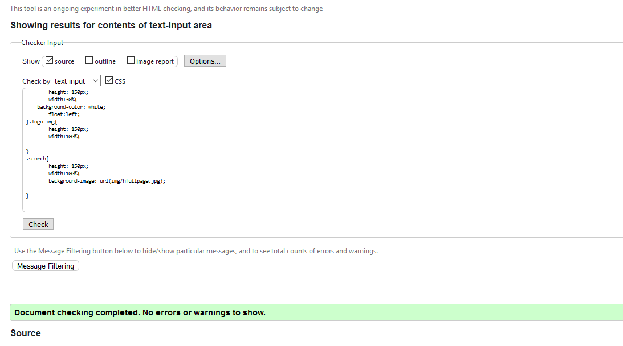

HTML Validation Screenshot:

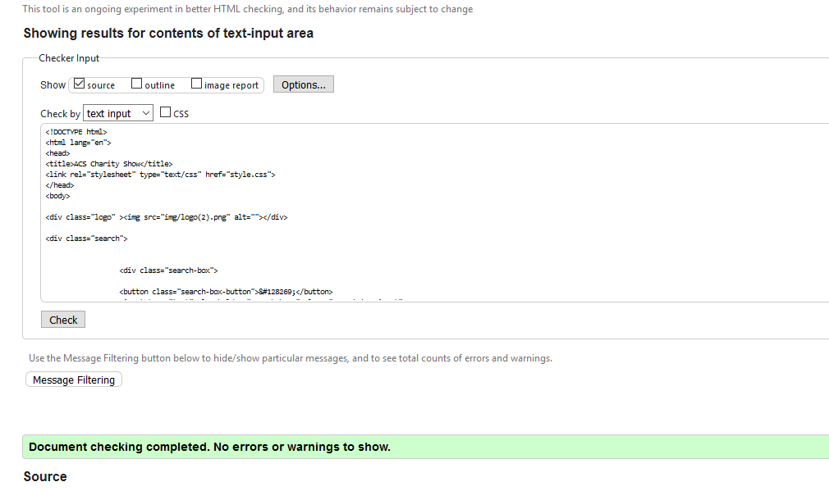

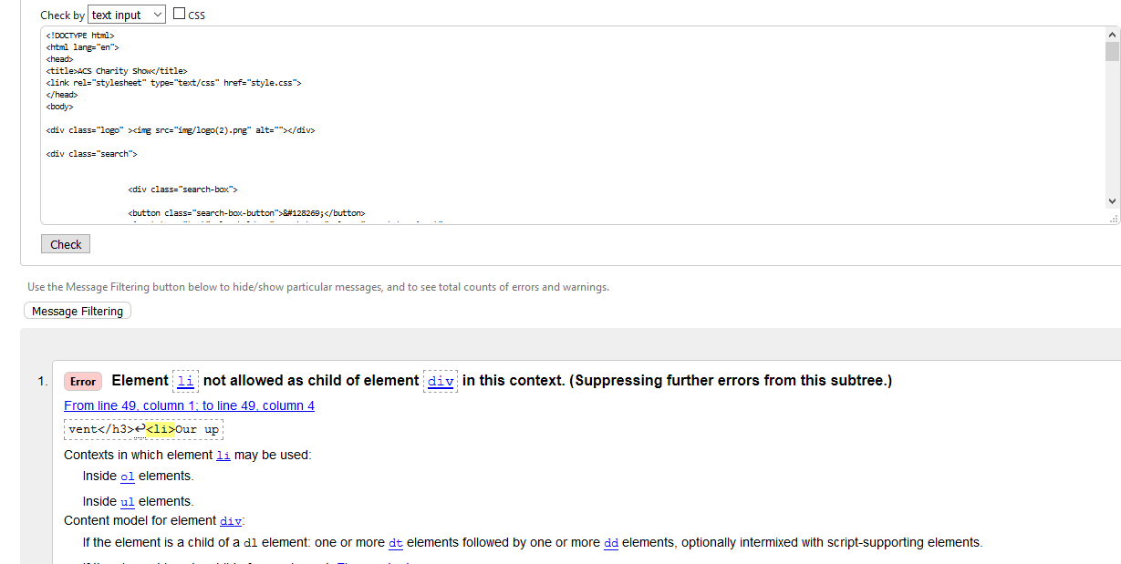It has one error.<li>not allow of element div in this contest.

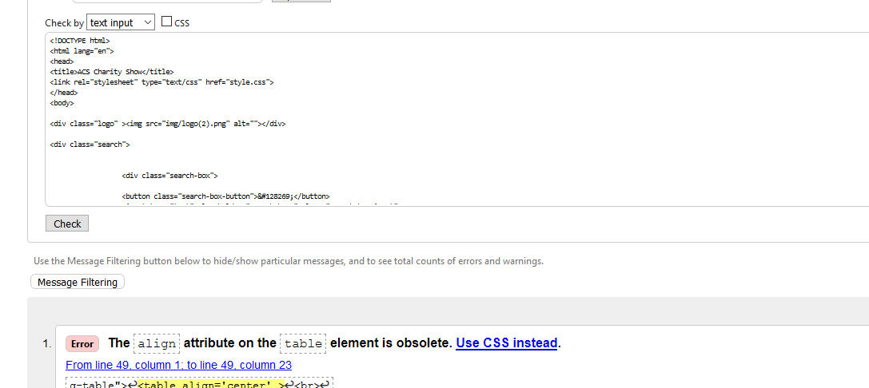

It has one error. align is css element so it never allow in html.

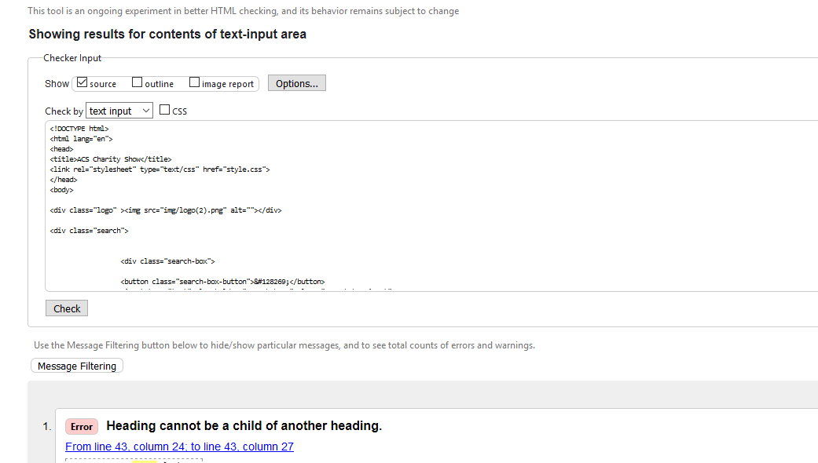

Heading cannot be a child of another heading

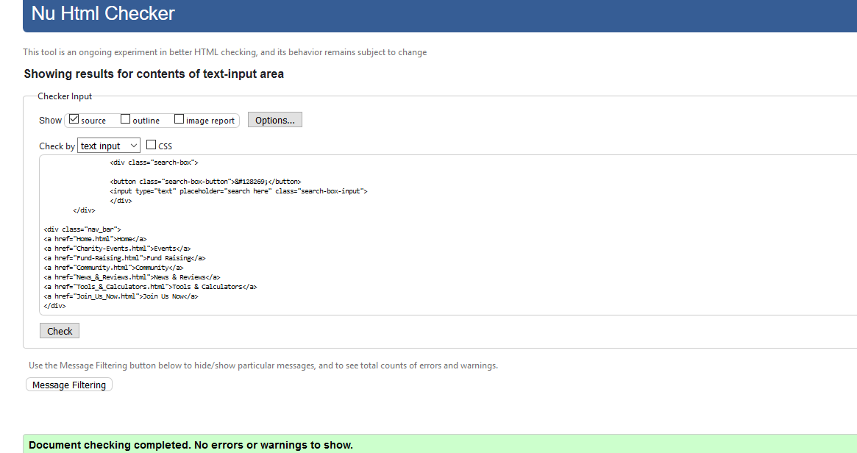

It have not any error..

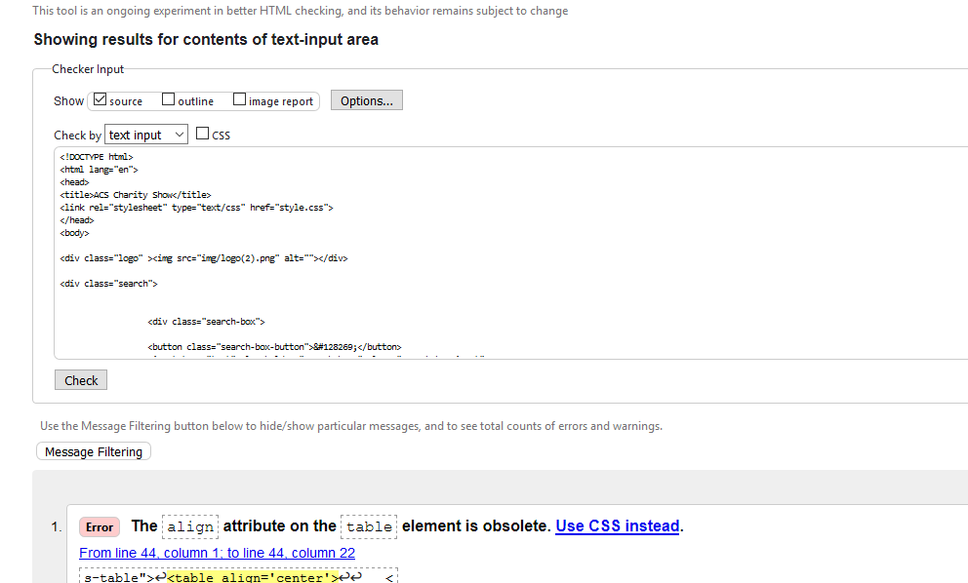

Align attribute is not allow in html.

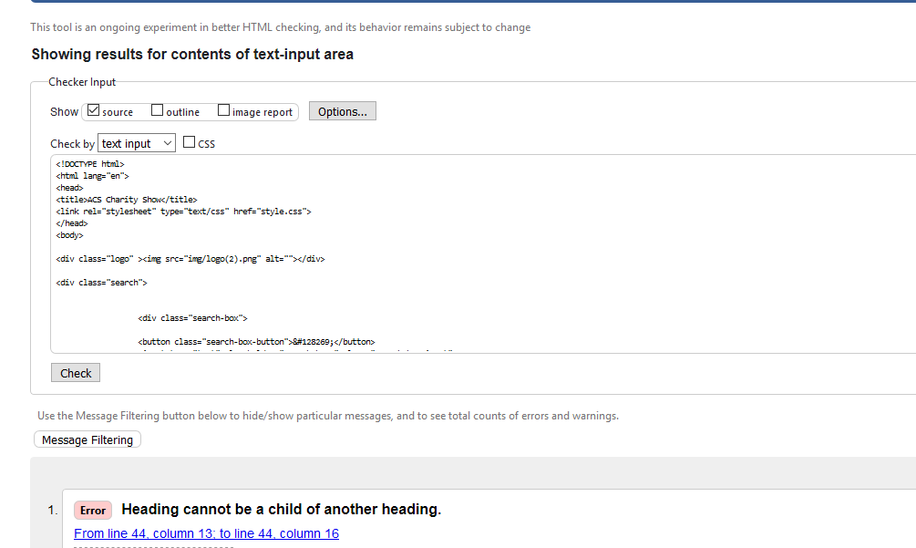

Heading cannot be a child of another heading.

Validation of Mobile.

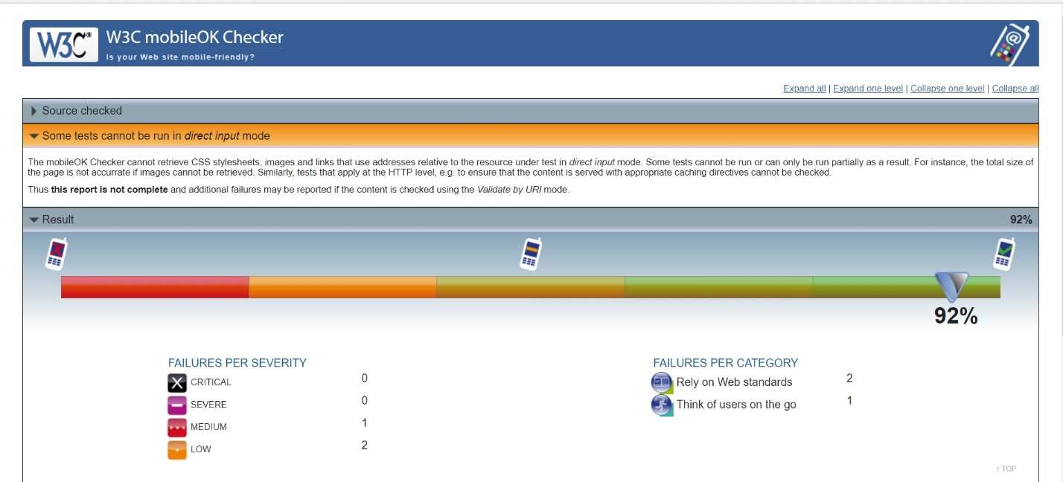

Compatibility of Web Browser -

Google Chrome:

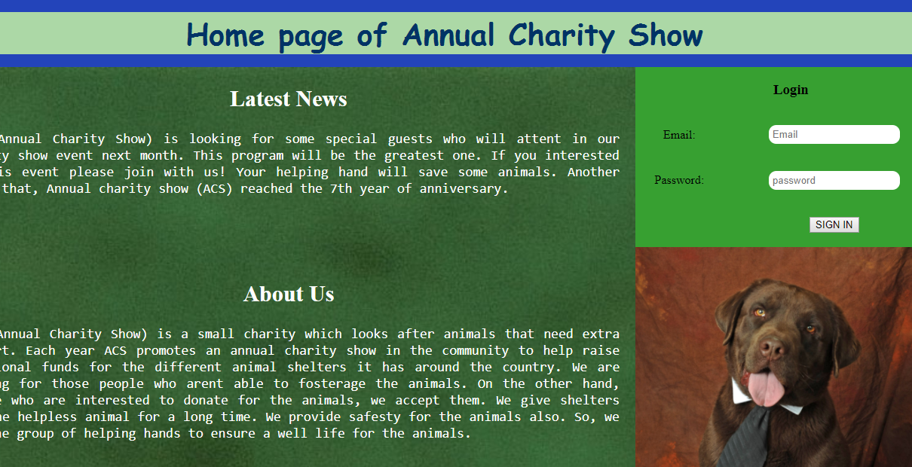

Homepage

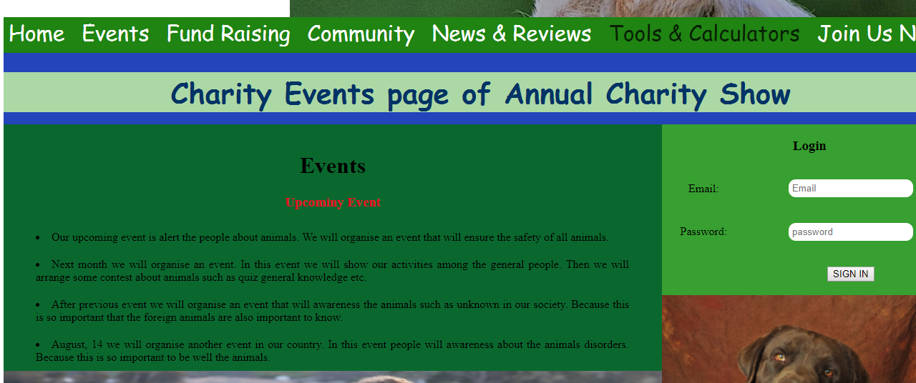

Charity Events page

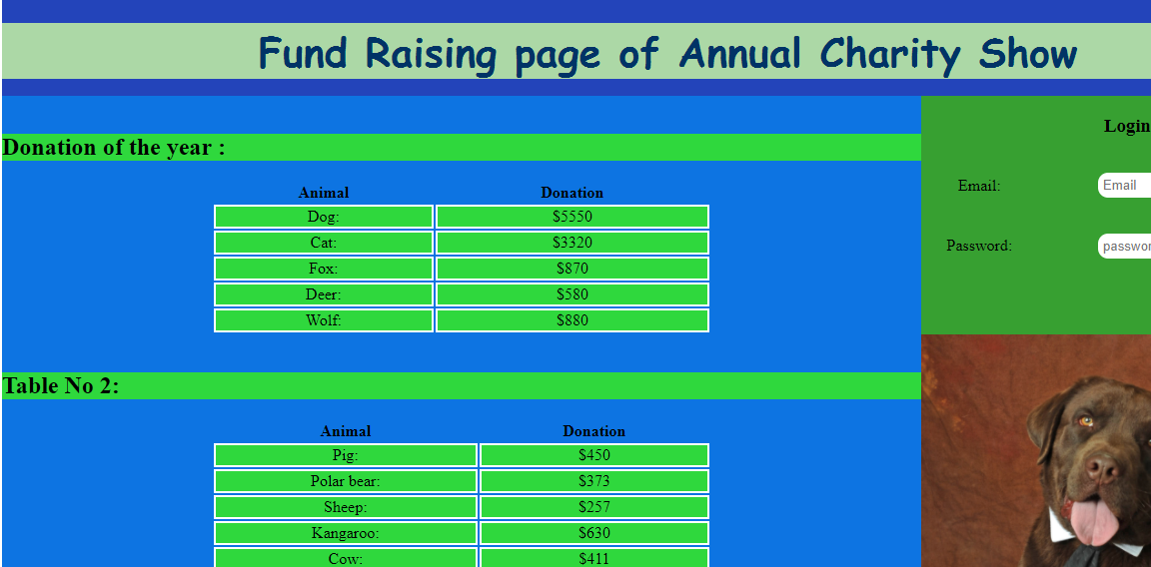

Fund Raising page

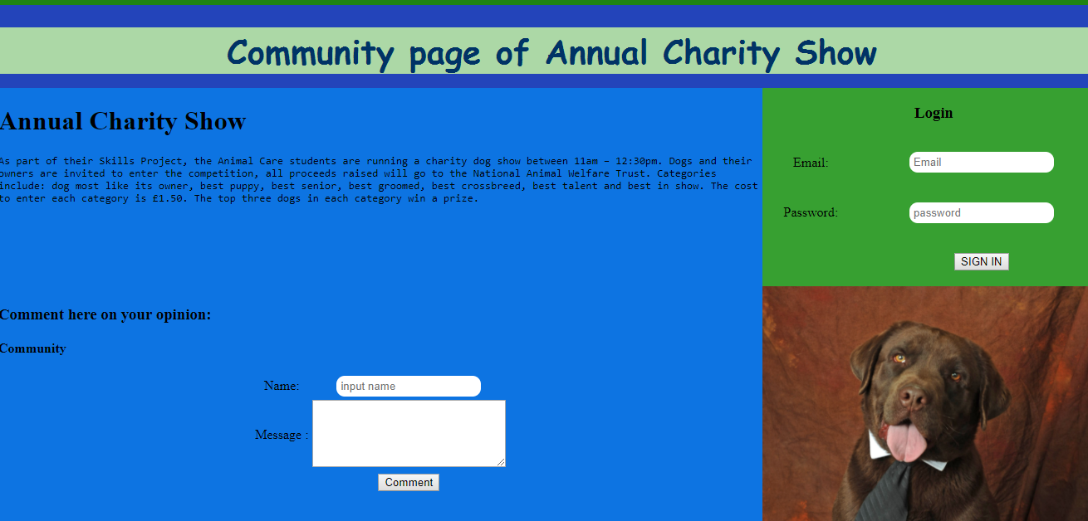

Community page

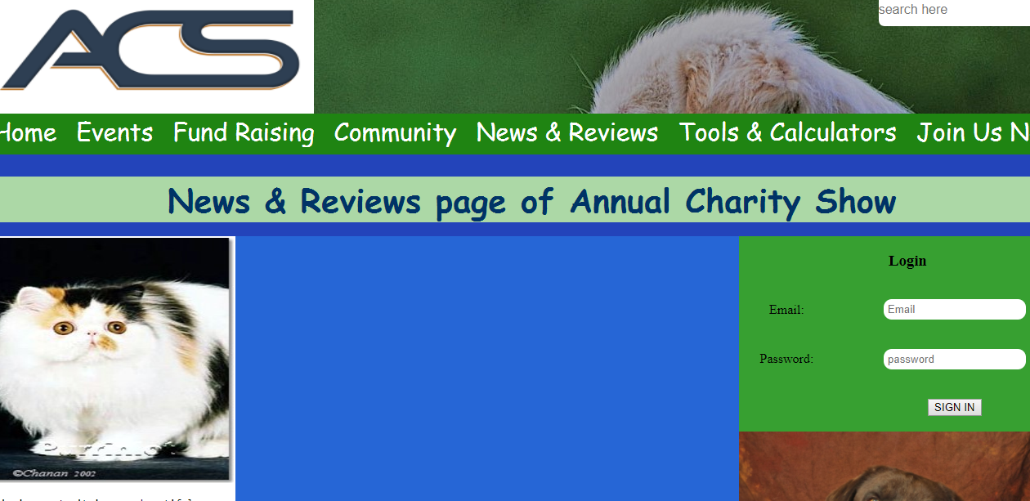

News & Reviews page

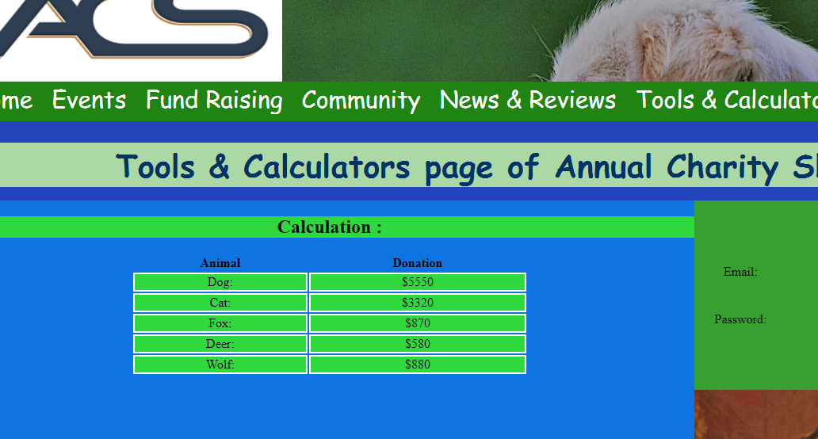

Tools & Calculators page

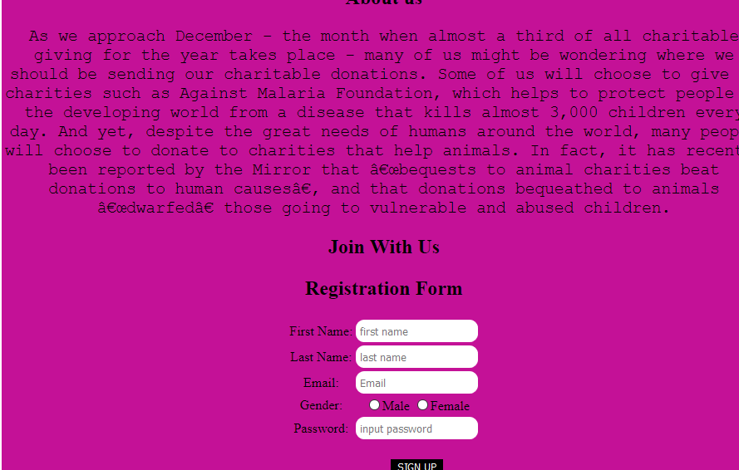

Join Us Now page

Mozilla Firefox:

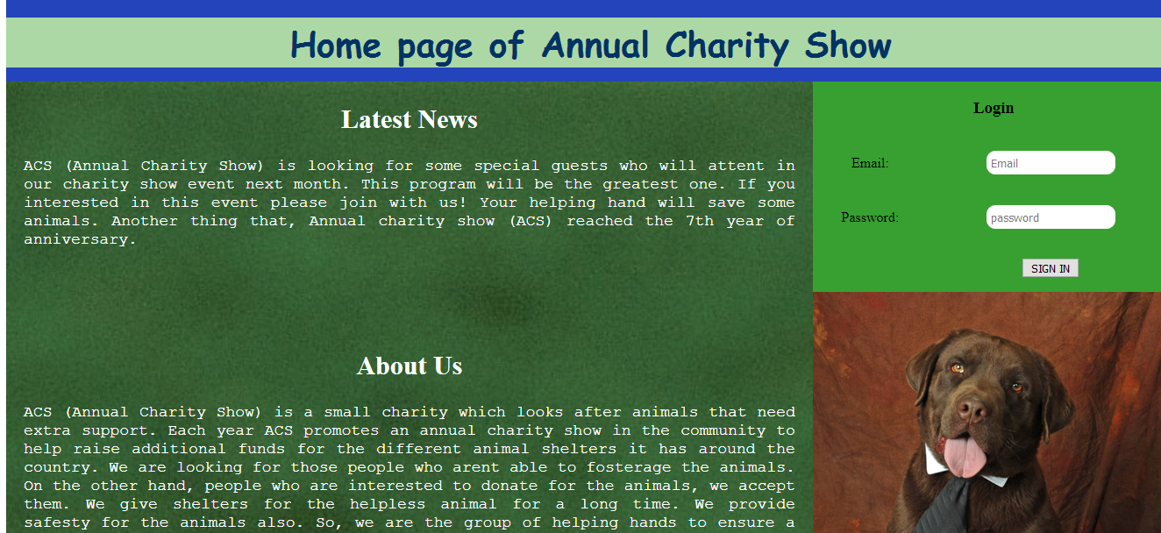

Homepage

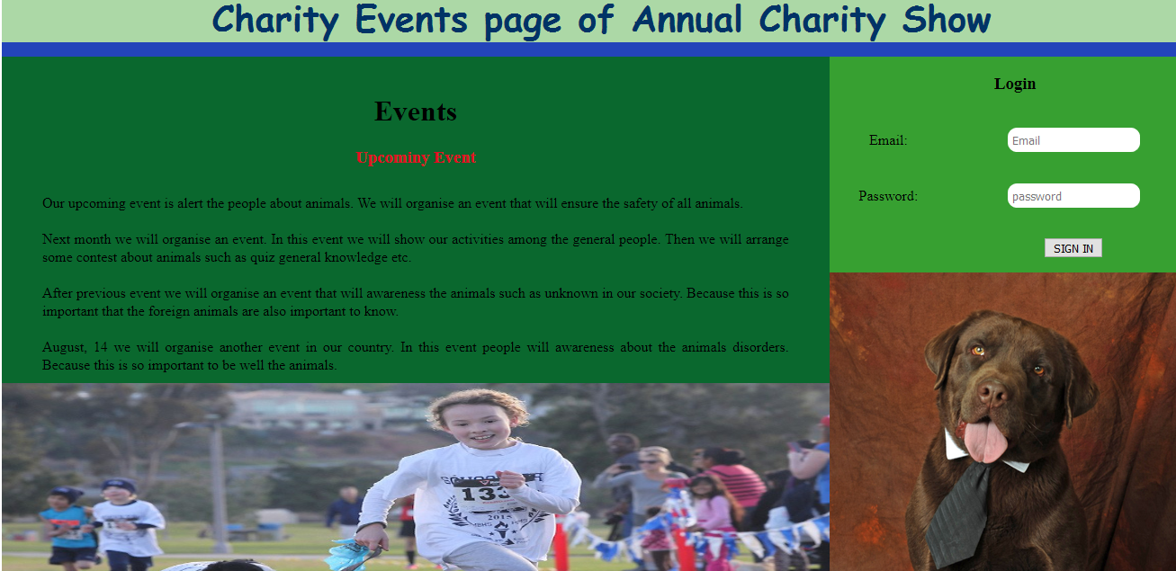

Charity Events page

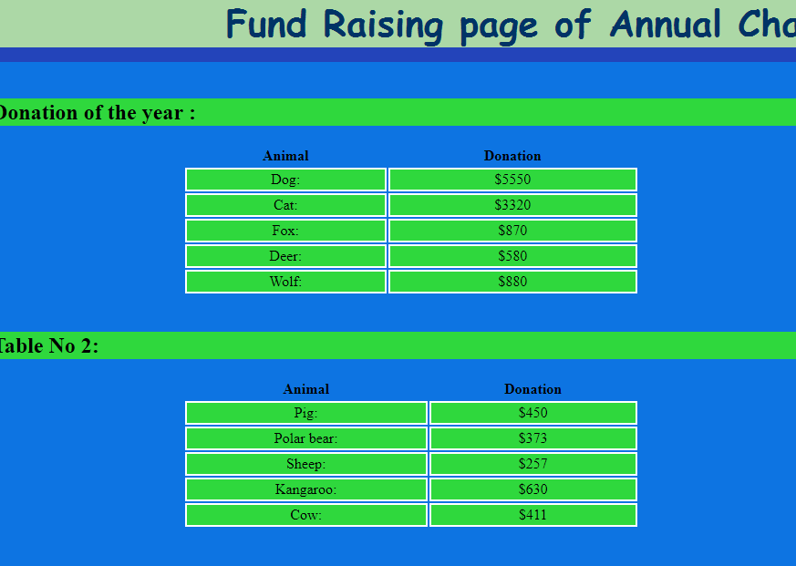

Fund Raising page

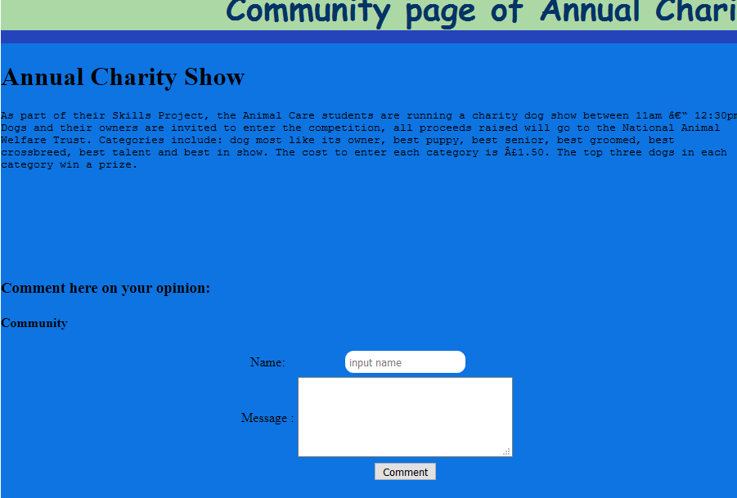

Community page

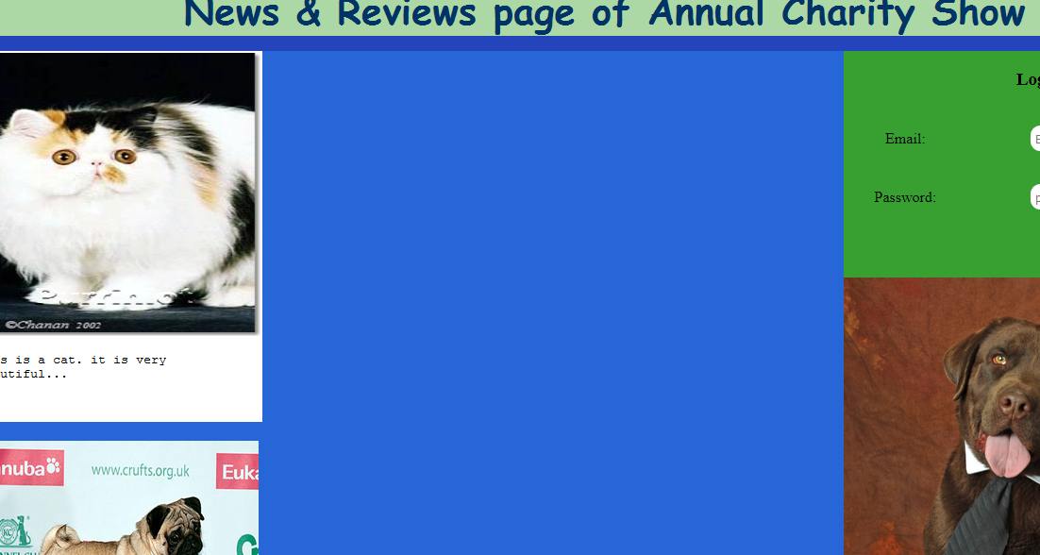

News & Reviews page

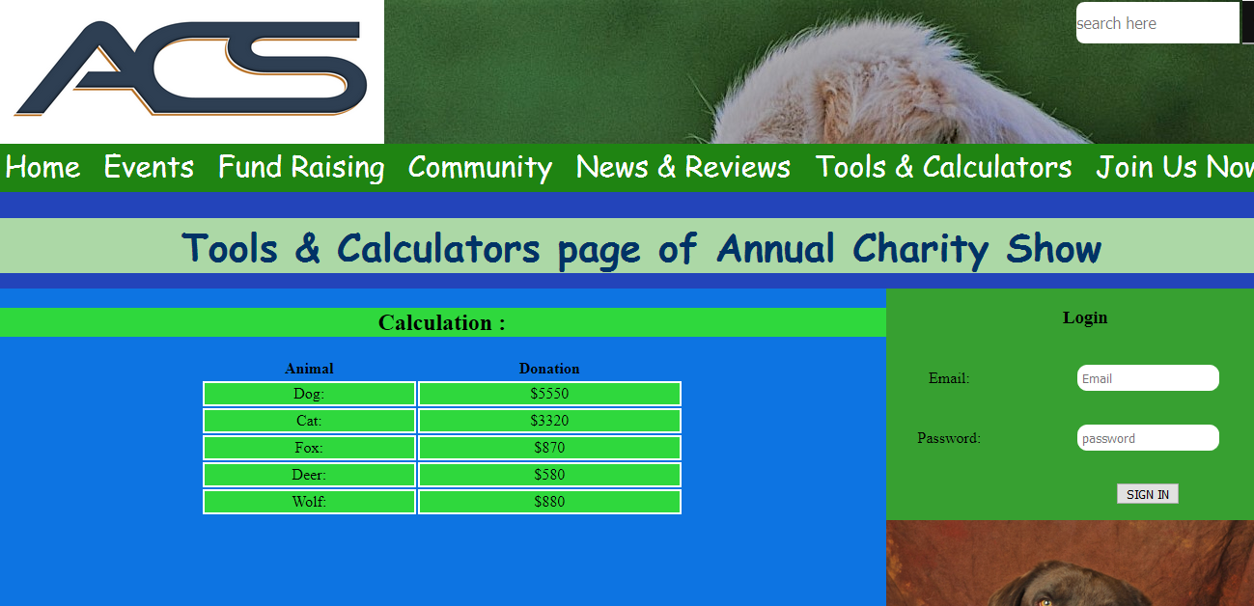

Tools & Calculators page



Join Us Now page

Testing Report:

* I am face some problem, hopefully as soon as possible I solve my problem. When I run this Annual Charity Show file for checked in W3C validator then I saw some different figure between Chrome and Mozilla Firefox. The font size have some variation and I also slow the text size have variation between two browers.

Task-4

Advantage and disadvantage of multimedia element:

|  |  |  |  |
| --- | --- | --- | --- |
| **Element Name** | **Element Format** | **Advantages** | **Disadvantages** |
| Image | Png | Image quality is standard. Quality is not change compress in any ratio | It cannot store multiple image in one file |
| Jpg/jpeg | Image quality is very high with tiny degree of compression. | It image quality is block of 8*8 pixel |
| Video | Mp4 | Less loss compression. | Files are not easy to edit or update. |
| WebM | For internet steaming it was build | All browser are not support this WebM. |

Different types of multimedia file format.

Advantages:

* It can make a greater impression.
* Adding multimedia elements, when viewer are view this elements they must be impress.
* Animations, when it is work for computer then it make all page very attracting and beautiful.

Disadvantages:

* Take more time to loading a video or audio file.
* Multimedia elements not as widely supported in every browser.

ACS website.

Advantages:

* When user can use navigation bar they must be move easily from one page to another page.
* User can do log in to social media, this is very easy for a user to using social media icon.
* 1024x768 size is perfect for this website and it was key with vertically move.

Disadvantages:

* HTML5 and CSS3 language is used for deigned this website only. For using JavaScript, we develop and too much attractive in this website.
* It have not used any map.

Suggestion for Improvements:

* If we realize that this is too much need for more attractive and need to develop we use some language. This language is JavaScript, WordPress, and jQuery etc.
* If we want to more efficiently then we need to adding some navigation bar..

Further Developments:

* If we want to this website is more and more attracting then need to use JAVA and PHP language with HTML and CSS.
* If we linking this website to another websites it must be provide search engine result.

CSS3 for Mobile.

Advantages:

* It makes the website move quickly.
* If we want to this website is done by responsive to mobile devices then we need to use CSS3.
* It helps improve to site speed.
* Mobile user can easily and quickly run and visit the site in mobile

Disadvantages:

* Is does not cover all requirement to respond in mobile.

Conclusion:

In this document I have already describe all component whose are needed for this task. I hope this website help the ACS company finally they are benefited.